Exercise 5

- List all employees who hold the titles of “Senior Programmer “ and Multimedia Programmer”.
SELECT * FROM employee_data WHERE title IN ('Senior Programmer', 'Multimedia Programmer');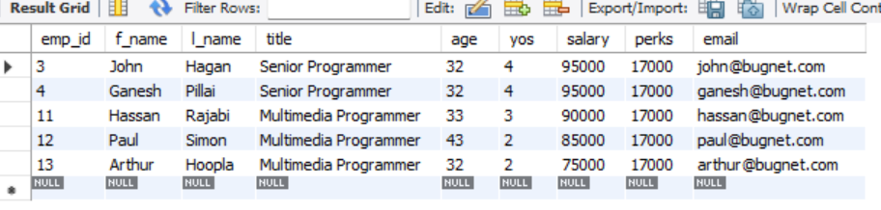
- List all employee name with salaries for employees who draw between $70000 and $90000.
SELECT f_name, l_name, salary FROM employee_data WHERE salary BETWEEN 70000 AND 90000;
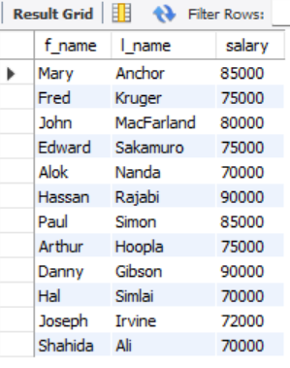
- What will the following statement display?
select f_name, l_name, title from employee_data where title not in ('Programmer', 'Senior Programmer', 'Multimedia Programmer');
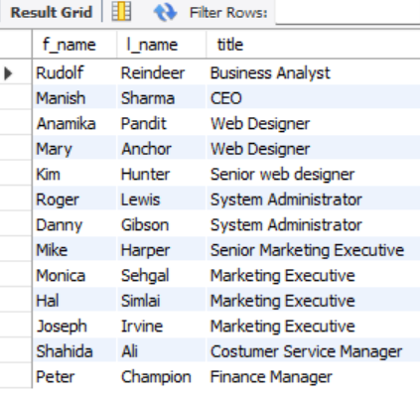
- Here is a more complex statement that combines both BETWEEN and IN. What will display?
select f_name, l_name, title, age from employee_data where title not in (‘Programmer’, ‘Senior Programmer’, ‘Multimedia Programmer’) and age not between 28 and 32;
